Succession Plan
Agency Name
Insert date

Additional text (optional)

503-XXX-XXXX
Email (optional)
Agency Webpage (optional)

TABLE OF CONTENTS

Assessment | Mission, Vision, Values 1

Identification | Highly Critical and Critical Positions 2

Development | Competency Development Plans 2

Evaluation | Competencies, Employee Goals, Recruitment Strategies 3

Action Plan 4

Assessment | Mission and Vision

Mission
Include supporting text further defining the mission and how it relates to the employees of the agency.
Use this box to highlight any information (if any).

Vision
Agency Vision.

Values
Agency Values.

Future Workforce
Upcoming agency changes and future work and potential challenges (i.e., operational changes, funding changes, recruitment/retention challenges).

Identification | Critical/Highly Critical Positions

Explain the direct business impact of not having the staff and competencies the agency needs in this position (consider the immediate impact as well as future impact). Specifically detail the consequences.

Highly Critical
- Position Number One
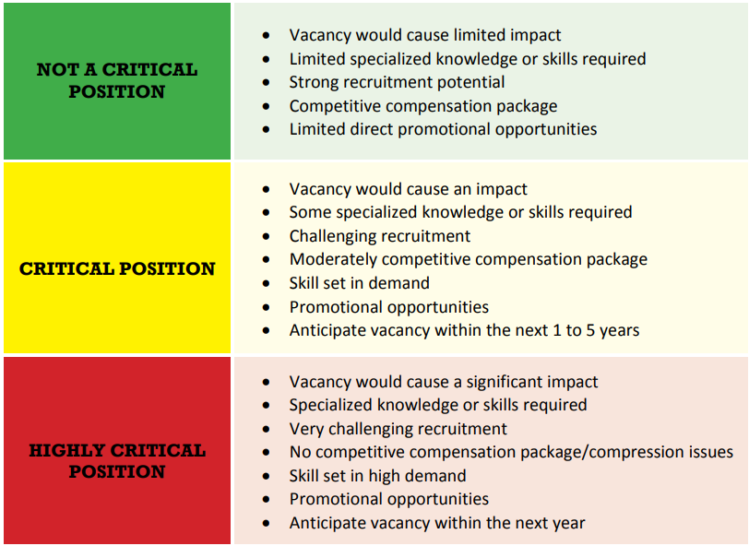
  - Competencies of Position
  - Why identified as Highly Critical (see factors)
- Position Number Two
  - Competencies of Position
  - Why identified as Highly Critical
- Position Number Three
  - Competencies of Position
  - Why identified as Highly Critical

Critical
- Position Number One
  - Competencies of Position
  - Why identified as Critical
- Position Number Two
- Competencies of Position
- Why identified as Critical
- Position Number Three
  - Competencies of Position
  - Why identified as Critical

Development | For Critical and Highly Critical Positions

Highly Critical
- Position Number One
  - Development plan for competency development (how are you going to build the bench strength for this position).
  - What are potential recruitment/retention challenges for this position and how do you plan to overcome them?
  - What are the skill development challenges in relation to the existing and future workforce (i.e., current employees need to develop new skills, specialized skills/degree/license are required, etc.) and how do you plan to overcome them?
- Position Number Two
  - Development plan for competency development (how are you going to build the bench strength for this position).
  - Gaps: what are potential recruitment/retention challenges for this position?
  - What are the skill development challenges in relation to the existing and future workforce (i.e., current employees need to develop new skills, specialized skills/degree/license are required, etc.) and how do you plan to overcome them?
- Position Number Three
  - Development plan for competency development (how are you going to build the bench strength for this position)
  - Gaps: what are potential recruitment/retention challenges for this position?
  - What are the skill development challenges in relation to the existing and future workforce (i.e., current employees need to develop new skills, specialized skills/degree/license are required, etc.) and how do you plan to overcome them?

Critical
- Position Number One
  - Development plan for competency development (how are you going to build the bench strength for this position).
  - Gaps: what are potential recruitment/retention challenges for this position?
  - What are the skill development challenges in relation to the existing and future workforce (i.e., current employees need to develop new skills, specialized skills/degree/license are required, etc.) and how do you plan to overcome them?
- Position Number Two
  - Development plan for competency development (how are you going to build the bench strength for this position).
  - Gaps: what are potential recruitment/retention challenges for this position?
  - What are the skill development challenges in relation to the existing and future workforce (i.e., current employees need to develop new skills, specialized skills/degree/license are required, etc.) and how do you plan to overcome them?
- Position Number Three
  - Development plan for competency development (how are you going to build the bench strength for this position).
  - Gaps: what are potential recruitment/retention challenges for this position?
  - What are the skill development challenges in relation to the existing and future workforce (i.e., current employees need to develop new skills, specialized skills/degree/license are required, etc.) and how do you plan to overcome them?

Agency-wide plans for competency development
Use this space to include any additional plans for competency development of positions outside of or in addition to Highly Critical and Critical. This section can include new/upcoming recruitment/retention efforts, training efforts, etc.

Evaluation | Competencies, Goals, and Recruitment Strategies

What are the agency’s plans to evaluate and revisit this plan to ensure the agency is on track in the following areas:

Highly Critical/Critical Positions
Has the work changed, has how the work is done changed or new programs added?

Competency Adjustment
How will the agency evaluate and adjust competencies?

Employee Goals
How will the agency evaluate employee goals (i.e., PAF guidelines to discuss employee interest and cross-training/promotional opportunities)?

Recruitment Strategies
What is the evaluation process to determine if the current and future recruitment and retention strategies are working and how will they be adjusted as needed?

Action Plan |

This section will help the agency outline the actions needed to align the agency’s strategic and succession plans. List the specific activities the agency will use, steps for completion and timeline to ensure agency’s performance. Agencies should include metrics where appropriate.

ACTIVITY #1:
Objective: (example) Improve recruitment process by reducing number of days an applicant is in the pipeline.

Targeted Completion Date: June 2024

Intermediate Milestones: 50% of applications at a 30-day turnaround by January 2024

Contingencies (if any): Potential staffing/funding changes

Metric Target: Baseline = 78 days, Target = 30 days

Metric Definition: 30 days from receipt of application to conclusion

ACTIVITY #2:
Objective:

Targeted Completion Date:

Intermediate Milestones:

Contingencies (if any):

Metric Target:

Metric Definition:

ACTIVITY #3:
Objective:

Targeted Completion Date:

Intermediate Milestones:

Contingencies (if any):

Metric Target:

Metric Definition:

Conclusion
Use this space to conclude any final thoughts about your succession plan. Explain how your plan supports the agency’s strategic plan, affirmative action and/or diversity plan(s).

