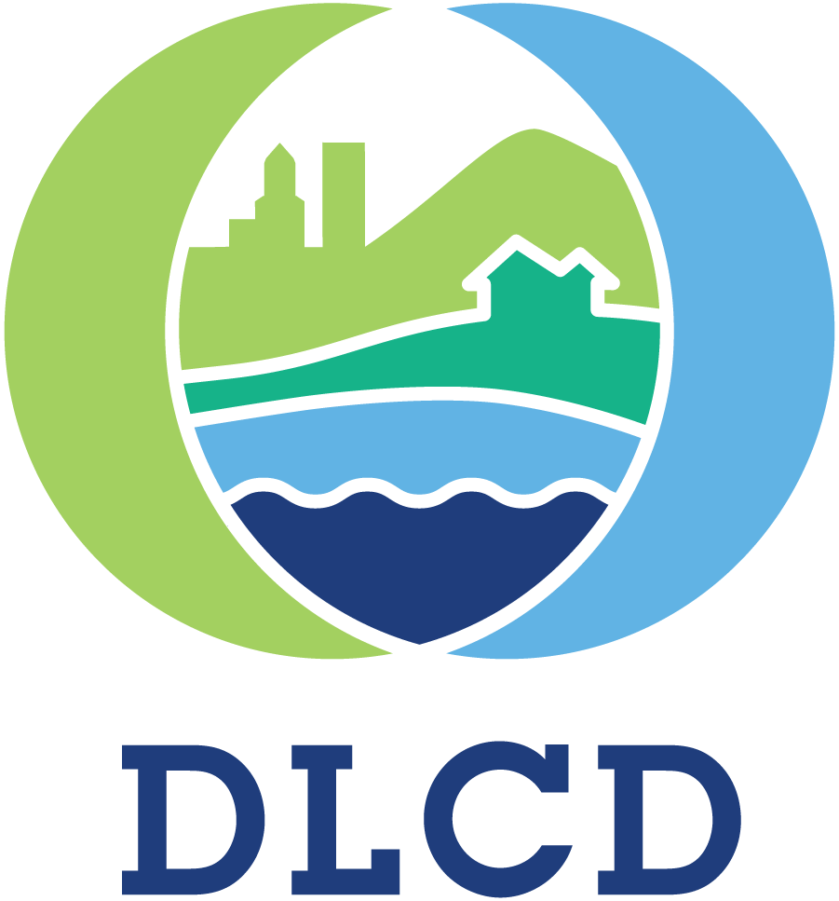 NOTICE OF ADOPTED CHANGE FOR DLCD USE
TO A COMPREHENSIVE PLAN OR File No.:
LAND USE REGULATION Received:
FORM 2

Local governments are required to send notice of an adopted change to a comprehensive plan or land use regulation no more than 20 days after the adoption. (See OAR 660-018-0040). The rules require that the notice include a completed copy of this form. This notice form is not for submittal of a completed periodic review task or a plan amendment reviewed in the manner of periodic review. Use Form 4 for an adopted urban growth boundary including over 50 acres by a city with a population greater than 2,500 within the UGB or an urban growth boundary amendment over 100 acres adopted by a metropolitan service district. Use Form 5 for an adopted urban reserve designation, or amendment to add over 50 acres, by a city with a population greater than 2,500 within the UGB. Use Form 6 with submittal of an adopted periodic review task.

Jurisdiction:
Local file no.:
Date of adoption: Date sent:
Was Notice of a Proposed Change (Form 1) submitted to DLCD?
Yes: Date (use the date of last revision if a revised Form 1was submitted):
No
Is the adopted change different from what was described in the Notice of Proposed Change? Yes No
If yes, describe how the adoption differs from the proposal:

Local contact (name and title):
Phone: E-mail:
Street address: City: Zip:

PLEASE COMPLETE ALL OF THE FOLLOWING SECTIONS THAT APPLY
For a change to comprehensive plan text:
Identify the sections of the plan that were added or amended and which statewide planning goals those sections implement, if any:

For a change to a comprehensive plan map:
Identify the former and new map designations and the area affected:
Change from to acres. A goal exception was required for this change.
Change from to acres. A goal exception was required for this change.
Change from to acres. A goal exception was required for this change.
Change from to acres. A goal exception was required for this change.
Location of affected property (T, R, Sec., TL and address):
The subject property is entirely within an urban growth boundary
The subject property is partially within an urban growth boundary
If the comprehensive plan map change is a UGB amendment including less than 50 acres and/or by a city with a population less than 2,500 in the urban area, indicate the number of acres of the former rural plan designation, by type, included in the boundary.
Exclusive Farm Use – Acres: Non-resource – Acres:
Forest – Acres: Marginal Lands – Acres:
Rural Residential – Acres: Natural Resource/Coastal/Open Space – Acres:
Rural Commercial or Industrial – Acres: Other: – Acres:
If the comprehensive plan map change is an urban reserve amendment including less than 50 acres, or establishment or amendment of an urban reserve by a city with a population less than 2,500 in the urban area, indicate the number of acres, by plan designation, included in the boundary.
Exclusive Farm Use – Acres: Non-resource – Acres:
Forest – Acres: Marginal Lands – Acres:
Rural Residential – Acres: Natural Resource/Coastal/Open Space – Acres:
Rural Commercial or Industrial – Acres: Other: – Acres:
For a change to the text of an ordinance or code:
Identify the sections of the ordinance or code that were added or amended by title and number:

For a change to a zoning map:
Identify the former and new base zone designations and the area affected:
Change from to Acres:
Change from to Acres:
Change from to Acres:
Change from to Acres:

Identify additions to or removal from an overlay zone designation and the area affected:
Overlay zone designation: Acres added: Acres removed:
Location of affected property (T, R, Sec., TL and address):

List affected state or federal agencies, local governments and special districts:

Identify supplemental information that is included because it may be useful to inform DLCD or members of the public of the effect of the actual change that has been submitted with this Notice of Adopted Change, if any. If the submittal, including supplementary materials, exceeds 100 pages, include a summary of the amendment briefly describing its purpose and requirements.

NOTICE OF ADOPTED CHANGE – SUBMITTAL INSTRUCTIONS

1. A Notice of Adopted Change must be received by DLCD no later than 20 days after the ordinance(s) implementing the change has been signed by the public official designated by the jurisdiction to sign the approved ordinance(s) as provided in ORS 197.615 and OAR 660-018-0040.
2. A Notice of Adopted Change must be submitted by a local government (city, county, or metropolitan service district). DLCD will not accept a Notice of Adopted Change submitted by an individual or private firm or organization.
3. Hard-copy submittal: When submitting a Notice of Adopted Change on paper, via the US Postal Service or hand-delivery, print a completed copy of this Form 2 on light green paper if available. Submit one copy of the proposed change, including this form and other required materials to:
Attention: Plan Amendment Specialist
Dept. of Land Conservation and Development
635 Capitol Street NE, Suite 150
Salem, OR 97301-2540
This form is available here: https://www.oregon.gov/LCD/CPU/Pages/Plan-Amendments.aspx
- 4. Electronic submittals may be sent via e-mail. Address e-mails to plan.amendments@dlcd.oregon.gov with the subject line “Notice of Adopted Amendment.”
FTP may be needed for large file submittals. Contact DLCD for FTP information.
The FTP site must be used for all .zip files regardless of size.
Include this Form 2 as the first pages of a combined file or as a separate file.
5. File format: When submitting a Notice of Adopted Change via e-mail or FTP, or on a digital disc, attach all materials in one of the following formats: Adobe .pdf (preferred); Microsoft Office (for example, Word .doc or docx or Excel .xls or xlsx); or ESRI .mxd, .gdb, or. mpk. For other file formats, please contact the plan amendment specialist at 503-373-0050 or plan.amendments@dlcd.oregon.gov.
6. Content: An administrative rule lists required content of a submittal of an adopted change (OAR 660-018-0040(3)). By completing this form and including the materials listed in the checklist below, the notice will include the required contents.
Where the amendments or new land use regulations, including supplementary materials, exceed 100 pages, include a summary of the amendment briefly describing its purpose and requirements.
7. Remember to notify persons who participated in the local proceedings and requested notice of the final decision. (ORS 197.615)

If you have any questions or would like assistance, please contact your DLCD regional representative or the DLCD Salem office at 503-373-0050 or e-mail plan.amendments@dlcd.oregon.gov.

Notice checklist. Include all that apply:
Completed Form 2
A copy of the final decision (including the signed ordinance(s)). This must include city and county decisions for UGB and urban reserve adoptions
The findings and the text of the change to the comprehensive plan or land use regulation

If a comprehensive plan map or zoning map is created or altered by the proposed change:

A map showing the area changed and applicable designations, and
Electronic files containing geospatial data showing the area changed, as specified in OAR 660-018-0040(5), if applicable

Any supplemental information that may be useful to inform DLCD or members of the public of the effect of the actual change

