**Energy Audit Report Template and Requirements**

# Overview

This document sets forth the expected standards for all Energy Audit Reports, to ensure that Contracting Agencies receive complete and accurate guidance to complete the services and scope described in the Energy Audits for School Buildings RFQ. Qualified energy auditing firms are expected to consistently meet these requirements. Failure to adhere to the requirements herein may be grounds for termination of a Prequalified List Agreement for Energy Auditing Services and/or withdrawal of the Oregon Department of Energy (ODOE) approval of an affected Scope of Work Approval. See Public Purpose Charge (SB1149) Schools Program Guidelines document for more detail on the role of energy audits in the program. This document, along with other resources for representatives of schools and energy audit firms, can be found on the [Public Purpose Charge (SB1149) Schools Program Guidelines](http://www.oregon.gov/energy/energy-oregon/Pages/SB1149-Program-Guidelines.aspx) web page.

The energy audit report template and requirements follows ANSI/ASHRAE/IES Standard 100-2015 Energy Efficiency in Existing Buildings which refers back to ASHRAE, *Procedures for Commercial Building Energy Audits, 2nd Edition* for many specifics (e.g., overall report layout, content, specific requirements) which are footnoted below.

**School Energy Audit Process**

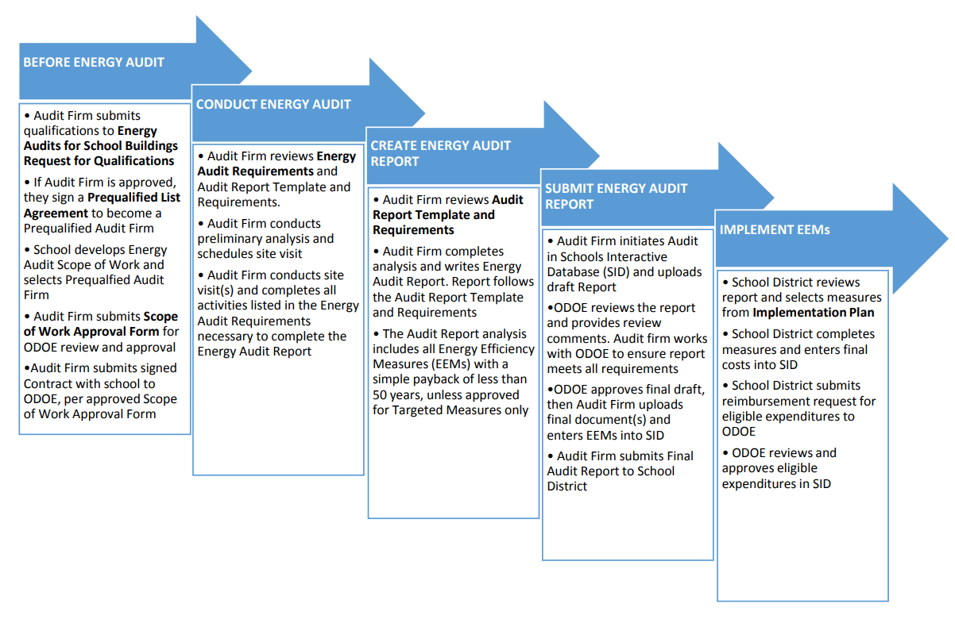

# 

# Report Requirements

All Energy Audits conducted under the Energy Audits for School Buildings RFQ must result in a final Energy Audit Report, which is submitted to ODOE through its [Schools Interactive Database (SID)](http://sid.odoe.state.or.us/).

The Energy Audit Report must pass a quality control and accuracy review completed by ODOE staff. This review will be greatly expedited by the audit firm following a robust internal quality control process as certified by the Senior Reviewer (certification at end of report template). The Report Template and instructions include built-in quality checks as shown in the Validating Individual EEM and Total EEM Savings table, as well as clear instructions throughout about required documentation and descriptions for key assumptions.

## General Requirements

General requirements apply to all Energy Audits are informed by data gathered during the audit, Contracting Agency (school district) needs and scope of work, and other Program requirements.

1. Energy Efficiency Measures (EEMs) and Simple Payback (SPB) Requirements
   1. Must analyze all pre-identified EEMs and systems contractually required by Contracting Agency and included in the Scope of Work, regardless of likely SPB.
   2. All analyzed EEMs must be included in the Energy Audit Report (See Energy Efficiency Measures section) and entered into SID.
   3. For a Whole-Building Energy Audit: All potential EEMs with a likely SPB less than 50 years must be analyzed. EEMs with a SPB of 50 years or greater can be listed in Other Measures section, but do not need to be analyzed, unless required by the Contracting Agency.
2. Energy Audit Reports must follow the Report Template & Instructions below.
3. For Targeted Energy Audits, the audit firm must specify in the Scope of Work exactly which sections of the Report Template will be omitted or modified.
4. Alternate formats must still include all Sections Headings and required information, be presented in a concise manner, and include all supporting data and documentation.
5. Any alternate formats may be used only after requesting and receiving prior written approval from ODOE.
6. Energy Audit Reports must be complete and well written. The report should demonstrate sufficient clarity to persons possessing moderate facility knowledge and average understanding of energy engineering principles.
7. Energy Audit Reports must be consistent and accurate. Unless otherwise noted in the instructions, reference values should be consistent with one another and consistent with all supporting documents, including spreadsheets, modeling files, and other related documents.

## Calculations and Energy Modeling Requirements

* 1. Calculations used in analyses must be supported with sufficient detail and include justification of all assumptions. Calculations completed in spreadsheets must not hide any cells or contain any data, formulas, or referenced cells that are not relevant to the particular audit.

1. Energy auditors **must use** **industry-accepted calculation methods** to predict achievable energy savings (e.g., ASHRAE Guideline 14, etc.). Calculation methods and assumptions must be clearly stated and supported. Accepted sources and citations may include metered data, peer-reviewed and industry-recognized white papers, energy clearinghouses, textbooks, and other similar sources. Use of such sources must be cited and clearly presented*.*
2. Must use Bin calculation methods or better for heating and cooling EEMs (following industry-standard methods such as ASHRAE Guideline 14). **Note:** BIN calculations may not be appropriate for addressing solar heat gain or thermal mass heat storage. If the calculations cannot reasonably account for these issues, whole building energy modeling (e.g., eQuest, etc.) or other calculation methods may be required.
3. For modeling, use building annual energy use hourly simulations of energy use by energy source suitable for determining both load analysis and the proposed energy use for each proposed EEM. Modeling with annual energy use hourly simulations must meet ASHRAE 90.1- 2016 Appendix G.
4. The Energy Audit Report must clearly and separately list the baseline and proposed (post-EEM) parameters and inputs. All modeling inputs should reflect actual building characteristics and conditions as described in the Energy Audit Report.
5. Additional requirements for use of modeling in the Energy Audit Report are located in the Appendices.

# Report Template & Instructions

Using the Energy Audit Report Template   
The Energy Audit Report Template consists of three major elements:

1. **Template**: Composed of the report sections with headings and sub-section headings that are required as part of the Energy Audit Report format. Page orientation (portrait vs. landscape) and margins can be adjusted to best fit tables and graphs.
2. **Requirements and Instructions**: Provide the specific details required in each section and instructional narrative.
3. **Charts and Graphs**: Used throughout the report as a required element of the report or included for reference for use during creation of the Energy Audit Report. The source files for these items are located in the Audit Report Template Tables Excel file located on the [Public Purpose Charge (SB1149) Schools Program website](http://www.oregon.gov/energy/energy-oregon/Pages/SB1149-Program-Guidelines.aspx).

The Report Template uses the following formatting:

# Section Heading Sub-Section Heading

**Individual narrative, charts, graphs, or other information**

*Instructions and specific requirements* (can be removed for creation of the Energy Audit Report)

**Common Unit and Acronym Definitions**

|  |  |
| --- | --- |
| **Unit** | **Description** |
| Btu | British Thermal Unit, amount of energy needed to cool or heat one pound of water by one degree Fahrenheit. |
| MBtu | Million Btus (also referred to as MMBtu). MBtus are calculated as # Btu divided by 1,000,000. |
| kBtu | Thousand Btus; is used in determining Energy Use Intensity (EUI). kBtus are calculated as # Btu divided by 1,000. |
| EUI | Energy Use Index/Intensity. Calculated as kBtu per year divided by total building square feet (kBtu/SF/Yr). |
| KW | Kilowatt; is an electricity demand unit for electric power capacity. Calculated as 1,000 watts. |
| kWh | Kilowatt hour; is an electric energy unit. Calculated as watts divided by 1,000 and multiplied by hours. |
| Therm | A standard natural gas energy unit; equal to 100,000 Btus. |
| R Value | Value for thermal resistance; is a measure of resistance of an insulating or building material to heat flow. |
| U Value | Value for thermal conductivity; is a measure of heat transfer coefficient. Calculated as 1/(R value). |

|  |  |
| --- | --- |
| **Acronym** | **Description** |
| HVAC | Heating, Ventilation, and Air Conditioning |
| EEM  SPB | Energy Efficiency Measure Simple Payback; Calculated by dividing the total EEM cost by the total EEM savings |
| DHW | Domestic Hot Water, heated water for washing and hygiene, but not for building heat |
| ASHRAE | American Society of Heating, Refrigeration, and Air-Conditioning Engineers |
| DDC | Direct Digital Controls |
| DX | Direct Expansion, represents mechanical cooling using refrigerant |
| RTU | Roof Top Unit, refers to packaged HVAC unit located on facility roof |
| CFM | Cubic Feet per Minute, a standard measure of HVAC air flows |

## **Energy Audit Report Template**

# Cover Sheet

* + School facility and school district name (Contracting Agency)
  + Physical address
  + Picture of the school
  + Program funding for audit (e.g., Public Purpose Charge reimbursement, Energy Trust, etc.)
  + Energy Audit type (e.g., whole building or targeted)
  + Energy Audit status (Draft or Final)
  + Energy Audit date and name of the Audit Firm

# Table of Contents

*Table of Contents should include all major headings, sub-section headings, and appendix sections. Include list of tables and graphs. Ensure table of contents is updated when report is finalized.*

# Report Summary

## General Information

**Nature and Scope of Report**

*Describe the scope of work, type of energy audit, and other relevant background information for the report.*

**Facility Description and Energy Consumption Overview**

*Provide a brief summary of building (size, vintage (age), shell, insulation, etc.), plus a short description of major energy-using systems.*

## Executive Summary of Energy Audit Findings

*Briefly describe the most significant opportunities for energy savings; focus on largest energy saving EEMs and any priorities set by Contracting Agency. If the identified EEMs would not bring a school to within the established* *EUI Target Range for Schools**, the energy auditor must provide any recommendations, investigation, or analysis that would be required for the facility to meet the target.*

## Building Energy Summary



*Table Instructions*

1. *Gross Square Footage (SF): Enter Gross Square Footage (as verified by the energy auditor).*
2. *TOTAL Baseline Energy Usage: Annual MBtu and Annual Energy Cost for entire building. Must match the* *Energy Consumption Profile table**. EUI and Cost columns are annual per square footage amounts.*
3. *TOTAL EEM Energy Saving: Annual MBtu and Annual Energy Cost are for entire building and must match the total amounts in the respective columns in the "EEM Summary" table. EUI and Cost columns are annual per square footage amounts.*
4. *TOTAL Proposed Energy Usage is the amount listed in “TOTAL Baseline Energy Usage” row minus the amount listed in the “TOTAL EEM Energy Savings” row.*
5. *EUI Target: Insert appropriate value for the facility based on EUI Target Range for Schools table.*
6. *No baseline adjustments are allowed for facility annual energy use or EEM savings calculations.*

## EUI Target Range for Schools

*This table is for reference only and does not need to be included in the Energy Audit Report.*

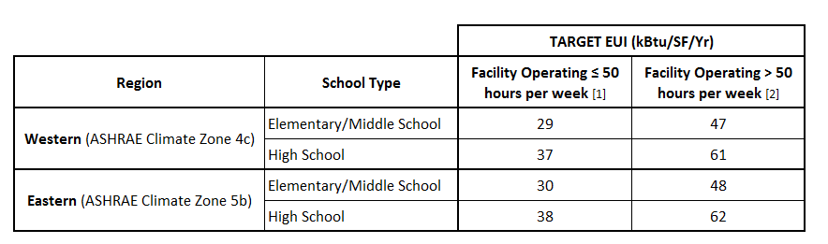

*For the purposes of determining weekly operating hours, energy auditors should follow the definition given in the Commercial Building Energy Consumption Survey (CBECS), on which the ASHRAE Standard 100-2015 targets are based:*

***Weekly Operating Hours:*** *The number of hours per week that a building is used, excluding hours when the building is occupied only by maintenance, security, or other support personnel. For buildings with a schedule that varies during the year, “Weekly Operating Hours” refer to the total weekly hours for the schedule most often followed. If operating hours vary throughout a building, the usual operating hours of the largest business in the building (based on floor space) determined the operating hours for the building.3 _*

This definition indicates that only the core operating educational hours of the school should be considered when determining weekly operating hours, and operating hours should not include such ancillary functions as maintenance or janitorial uses or limited evening or weekend activity for which only a portion of the facility is being used.

***It is expected that the majority of schools will be categorized into the less than or equal to 50 hours per week range.***

______________________

ANSI/ASHRAE/IES Standard 100-2015 Energy Efficiency in Existing Buildings, Table 7-2 Building Activity Energy Targets. The lower target range represents the value in ASHRAE Standard 100 table 7-2 with adjustments to incorporate the lower factor for schools from ANSI/ASHRAE/IES Standard 100-2015 Energy Efficiency in Existing Buildings, Table 7-3 Building Operating Shifts Normalization Factor.

2 ANSI/ASHRAE/IES Standard 100-2015 Energy Efficiency in Existing Buildings, Table 7-2 Building Activity Energy Targets. The upper target range represents the value in this ASHRAE Standard 100 table 7-2 with adjustments to incorporate the higher factor for schools from ANSI/ASHRAE/IES Standard 100-2015 Energy Efficiency in Existing Buildings, Table 7-3 Building Operating Shifts Normalization Factor.

3 CBECS Terminology: http://www.eia.gov/consumption/commercial/terminology.php

## Energy Efficiency Measure (EEM) Summary[1]



*Table Instructions*

1. *Include all EEMs with a calculated Simple Payback (SPB) of less than 50 years, and EEMs contractually required by the Contracting Agency in this table (see* *General Requirements**).*
2. *Sort/Order: EEMs should be analyzed and listed in order by 1) load reduction measures (e.g., envelope insulation), 2) distribution systems and associated equipment efficiencies (e.g., steam pipe insulation, boiler upgrades), and 3) plant and heat rejection systems (e.g., cooling tower)*
3. *Values listed for the EEM should account for all interactions between prior EEMs (per above instruction). When EEM savings are analyzed in isolation (e.g., HVAC replacement without related load reduction measure), these savings should be presented in the specific* [*EEM Section*](#_Energy_Efficiency_Measures) *of the report.*
4. *Interactions within lighting EEMs should be shown on the same row in the table above (i.e., electrical savings entered as a positive value (net of cooling savings if any) and any non-electric heating should be entered as a negative value in appropriate heating fuel column.) Assumptions on heating/lighting interactions (e.g., percentage of heat loss to conditioned space) should be explained in the* *EEM Section* *of the report.*
5. *Expected Table Customization/Adaption: Increase or decrease number of rows to match EEM count; Customize the Other fossil fuel/All Other headings and units (e.g., could add biomass, but still use MBtu units) as needed.*
6. *The TOTAL EEM Energy Savings row shows the sum of all EEMs included in the table. All figures must match the* *Building Energy Summary table* *(for relevant, respective columns).*
   * *If including mutually exclusive EEMs, list each as an individual row on the table. Only one of the mutually exclusive EEMs should be included in the TOTAL EEM Energy Savings calculation (i.e., include only the recommended EEMs as to not “double count” measures in the total). Please include footnote as to which EEM is included in TOTAL.*
7. *The TOTAL Baseline Energy Usage row must match the TOTAL Baseline Energy Usage values in the Building Energy Summary table and the* *Energy Consumption Profile table**.*
8. *The TOTAL Proposed Energy Usage row is the amount listed in TOTAL Baseline Energy Usage row minus the amount listed in the TOTAL EEM Energy Savings row. This must match the TOTAL Proposed Energy Usage (for relevant, respective columns) in the* *Building Energy Summary table**.*
9. *Any significant customization for other reasons needs to be authorized by ODOE in advance.*
10. *Add footnote(s) to table as needed.*

# Validating Individual EEM and Total EEM Savings

Total EEM Savings by End Use  
*This table compares the estimated energy savings of all selected EEMs to historical consumption. This should be used to ensure that estimates of the baseline end-uses and proposed energy-savings estimates are reasonable.[2] The energy auditor must verify that each EEM savings estimate is reasonable in comparison to the historical end use, which is based on measurement, survey data, or experience with similar sites.[3]*



*Table Instructions*

1. *All Baseline Use figures, by End Use Category and Total, must match those used in the* *Energy End Use Split Estimates* *table.*
2. *EEM savings columns should be match Total EEM Savings reflected elsewhere in report. Those savings should be allocated to the End Use Split category by fuel, based on where the savings are achieved.*
3. *Document and explain any assumptions used in the calculation of values presented in this table.*
4. *Customize/Adapt Table as appropriate for other fuels. Any other significant customization needed for a Targeted Audit requires pre-approval by ODOE in the Scope of Work.*
5. *Example table provided in the Excel file.*

Validation Narrative *Explain why the EEM energy savings presented in the tables above are reasonable. For individual EEMs with significant savings (as indicated in “Energy Savings % of Total Baseline Energy” column in* *EEM Summary table**), demonstrate why the savings are realistic. Demonstrate that the total savings relative to the baseline are realistic and why (e.g., cite improvements in efficiency, significant conservation actions, percent of building or systems affected, etc.).*

***Note:*** *EEMs that exhibit a high percentage of savings or result in a low EUI, require greater description in the Audit Report and may receive additional examination during ODOE review. Energy Auditors should double-check all results and correct unrealistic or unjustified savings before submitting to ODOE.*

# Energy Consumption

## Energy Provider(s) and Rate(s)



*Table Instructions*

1. *Electric utility rates should reflect applicable energy rate, kWh (e.g., marginal rate if in block schedule), demand charge/KW rate shown separately. DO NOT use blended rate.*
2. *For Other Fuels, use $/gallon for liquid fuels, $/ton or $/MBtu as per common practice (e.g., biomass) for solid fuels.*
3. *Customize/Adapt Table: Insert additional rows with separate information if multiple meters are present.*
4. *If there are multiple rates, explain multiple schedules (e.g., separate meter and schedule for athletic field).*

## Energy Consumption Profile



*Table Instructions*

1. *Time Period: Enter beginning and ending years for utility/energy bills. Must include at least two years of consecutive monthly data and two-year average. Data can be provided in calendar year or school year (June-July, which is used for Schools Interactive Database, SID). Additional monthly data may be added at the energy auditor’s discretion.*
2. *Electricity: Be sure to include all electric meters if there are more than one.*
3. *All Other Fuels: The data in this table must match the data used to produce the Energy Consumption graphs.*
4. *Revise the “All Other Fuels” column headers with the appropriate fuel name (e.g., “#2 Oil”) and enter appropriate unit in “All Other Fuels, (Unit)” column header (e.g., Gallons).*
5. *The 2-Year Average (Baseline Energy Usage) row must match the TOTAL Baseline Energy Usage values in the Building Energy Summary and Building Energy Summary tables.*
6. *Table Customization/Adaption: Any significant customization for reasons other than above must be authorized by ODOE in advance.*

## Energy Consumption Graphs

*Display two years of consumption data on line graph (months on x-axis with years as stacked lines). All electricity, natural gas, and other fuels used at the facility need to be graphed (each on separate chart) following content and format below.*

**Electricity Graph Example**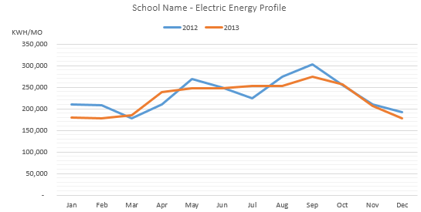

**Natural Gas Graph Example**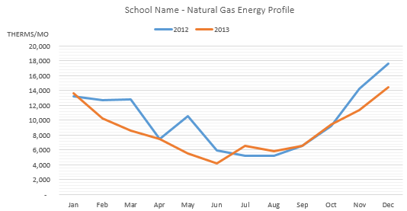

**Energy Consumption Narrative***[4]  
Include brief narrative describing seasonal utility usage patterns and anything that stands out (e.g., note and explain any anomalies, etc.). Explain any trends. As relevant, correlate with features that may drive consumption profiles (e.g., occupancy, use patterns, weather, etc.). Explain relationship to end use splits and opportunities for energy savings as relevant.*

# Energy End Use Split Estimates

*Energy end use split estimates may be calculated (with whole-building annual energy simulation tools or spreadsheets) or measured[5]. See* *Energy End Use Calculations* *in the Appendices for more detailed requirements regarding documenting how the end use estimates were derived.*

*Energy auditor must estimate the energy use of all end uses that individually comprise more than 5% of total historic building energy use*[6]*. The end use split estimates must sum to within 10% of historical baseline facility energy use. The energy estimates calculated in the end use analysis must form the basis for energy savings calculations for EEMs elsewhere in the energy audit report.*

*The calculations and related assumptions used for the estimates should be included in the Appendix.*



*Table Instructions*

1. *All Use values, by End Use Category and Total, must match those used in the Total EEM Savings by End Use table. The end use split estimates must sum to within 10% of historical baseline facility energy use in the Energy Consumption Profile.*
2. *Expected Table Customization/Adaption: Revise the “All Other Fuels” column header with the appropriate fuel name (e.g., “#2 Oil”) and enter appropriate unit in “All Other Fuels, (Unit)” column header (e.g., Gallons). Any other significant customization for other reasons needs to be authorized by ODOE in advance.*

**Energy End Use Narrative** *Briefly explain the methodology used to estimate the end use splits (methodology details to be included in the* *Appendices**). Describe any major anomalies in any end use or related EEM, where relevant.*

# Building Occupancy



*Table Instructions*

1. *For the Column Heading “% of Bldg Used,” calculate the in-use building square footage divided by the total square footage, shown as a percentage.*
2. *Expected Table Customization/Adaption: Add rows to accommodate the entire list of unique space types. Any other significant customization needs to be authorized by ODOE in advance.*

**Building Occupancy Narrative** *Provide a brief narrative describing typical daily, weekly, and annual occupancy patterns. Be sure to note unusual patterns, after-school, weekend or summer occupancy, especially if they affect total or seasonal energy usage. This information is also useful when comparing to HVAC schedules and understanding opportunities or limitations for certain EEM savings.*

# Facility Description

*The building description must contain sufficient baseline details about the building (e.g., year built, number of remodels, type of construction), including measured and/or verified square footage.*

General*Building layout (show sections and years if remodeled), general construction, types of spaces/general layout, square footage. Note any differences between total, conditioned, unoccupied square footages.*

## Envelope

*Describe construction, layers, R-values/U-values, condition, presence of asbestos or other materials as relevant. Energy Auditor may include table with various component R-values or total assembly U-values.*

Roof/Ceiling:   
*Construction, attic or built-up, insulation type and placement, R-value, and area for each unique section of the facility.*

Walls:   
*Construction, insulation type, R-value, and area for each unique section of the facility. Note any weather sealing issues.*

Windows:   
*Glazing type, frame type, location and dimension (area) of each unique type, shading, orientation, operability, weather-stripping, and condition. Include U or R-values, approximate Solar Heat Gain Coefficient (SHGC), and window tint description. Note if specific windows are left open for purposes of ventilation or comfort issues.*

Doors:   
*Types, number, and size of each unique type. Describe weather-stripping, condition, and self-closing mechanisms. Note any doors that tend to be left open.*

***Note:*** *Wall, floor, roof or attic insulation should described with R-values of all layers of construction, and show how the totaled R-values were developed.*

## Other

* *Insert floor plans that include all buildings on campus. For each building, show building sections and notes eras of construction if remodeled. Simple floor plans should include current room and building names, including classrooms and accessory buildings (e.g. portables).*
* *Pictures of major building elevations and exterior. Include additional photos and descriptive captions of all building elements, systems, or conditions that are related to the proposed EEMs (included in* *EEM Section* *or Appendix).*
* *Photographs should include descriptive captions and be large enough to clearly see in 8.5X11 inch page size.*

# Energy Using Systems Description

*The system descriptions must contain sufficient detail to understand the building’s major energy using systems including:* ***HVAC, Domestic Hot Water, Lighting, Plug loads, and Other****.*

* *Narrative should include explanations on the system type, age, nameplate capacity, condition, controls, area served by each unit, operating schedules and sequence of operation/controls overview, current capabilities and limitations, and any significant known or suspected issues.*
* *This information should provide the necessary background to understand the Existing Conditions narrative in each* *EEM section**.*
* *When modeling is used, the description must provide sufficient detail for the development of model input values for the energy models.*
* *Summary findings from the equipment surveys should also be included in the narrative. The full* *equipment surveys* *must be included in the Appendix.*
* *Describe any operation or conditions that are outside of recommended or standard ranges (e.g., excessive run times, over-lit areas, high or low setpoints, etc.) and provide corroborating documentation.*

Heating, Ventilation, and Air Conditioning (HVAC)  
*Include summary description of how the building is heated, cooled and ventilated. Reference the HVAC system equipment, HVAC zone(s) floor plan, how the equipment is controlled, and provide an overview of schedules and set points. Include equipment surveys in the Appendix.  
  
Descriptions should be grouped into the following categories:*

**Boiler and Chiller Plant***Describe boiler and chiller plant(s), along with the distribution and condensate systems and cooling towers, where applicable. Describe the air handling or terminal units served by each plant and the zones they serve. Briefly describe seasonal shutdowns, daily on/off, freeze protection, high limit lock outs, lead/lag, etc., as appropriate.*

**Airside and Other HVAC System Equipment***Describe system equipment (e.g., furnaces, unit ventilators, radiators, heat recovery, etc.) and the zones they serve. Briefly describe fan schedules, ventilation, economizer capability, setpoints, etc., as appropriate.*

**Packaged Units***Describe packaged unit equipment (e.g., DX, Heat pumps, RTUs, etc.) and the zones they serve. Briefly describe fan schedules, ventilation, economizer capability, setpoints, etc., as appropriate.*

**Building-Level HVAC Controls***Individual equipment controls should be included with notations of the related equipment that they control. Building-level/global controllers should be explained in the narrative. Include general description (point by point is not required) of existing control configuration and operating sequence.*

Domestic Hot Water (DHW) *Include summary description of equipment, fuel type, capacity, area served, and settings. This should include a description of tank and distribution piping insulation, end uses (e.g., showers for PE class and sports, kitchen, laundry, etc.). Note the major end-use fixture types (e.g., faucets, showers, dishwashers, etc.) and if any end use equipment has unexpectedly high hot water usage or leaks*. *Include equipment survey in the Appendix.*

Lighting (Interior and Exterior)  
*Include summary description of equipment, areas served, and controls. Include lighting survey in the Appendix.*

Plug loads and Other Equipment  
*Include summary description of location, type, and quantity. Include equipment survey in the Appendix.*

# Energy Efficiency Measures (EEMs)

*Provide one complete section for each EEM. Specific Requirements for Controls and Lighting EEMs are described in the* *EEM Related Appendices**.*

*The following elements for each EEM (for each energy audit type and each school) are required:*

## EEM Number and Title:

*Number and title for each EEM. The EEM number assigned must be consistent throughout the report and included in the measure summary table.*

## EEM Description*:*

**Existing Conditions**

*Provide a complete description of existing conditions.* *Include a summary of site data including monitoring results, measurements, and other relevant information. Include sketches, photographs and expanded narrative for clarity where applicable or required.*

*Any equipment information (e.g., horsepower, capacity, nameplate power, etc.) must be provided, as well as a citation of data sources (e.g., data logging, cut sheets, design drawings, engineering assessment, etc.) for each critical value and condition.*

**Proposed Conditions**

*Provide a complete description of each EEM proposed. Describe how the system/operation would be made more efficient or how the new equipment would reduce energy use. Description must be sufficient to ensure school district staff understand how proposed EEM can be implemented or how this information will be used by an engineer/contractor for design and specification work.*

* *Must note if EEM is mutually exclusive from any other EEMs (e.g., providing two alternative recommendations to address one system).*
* *Recommendations must meet current code requirements and standard design recommendations (e.g., IES, ASHRAE, Oregon Energy Efficiency Specialty Code, and Oregon Mechanical Specialty Code).*
* *Describe any repairs or operational changes required for the EEM to be effective. Outline how implementation of EEM may impact operations and maintenance (O&M) procedures and cost, any new operating skills required, recommended training & hiring, and any impact on existing equipment life.*
* *Briefly describe any other impacts on occupant health, comfort or safety, as well as non-energy benefits, especially improvements to health, safety and environment, decreases in equipment run time, and maintenance labor hours.[7] This should also include:*
  + *Required material disposal and recycling (e.g., PCB ballasts, asbestos, refrigerants)*
  + *Ventilation and indoor air quality (IAQ) issues (e.g., new equipment may increase ventilation)*
  + *Effects on classroom acoustics or aesthetics*

**Commissioning Requirements***Note if any commissioning is required for the EEM. Per the Program Guidelines, Commissioning is required for:*

* *All boiler or chiller measures exceeding $100,000*
* *All other HVAC measures and all HVAC controls measures exceeding $50,000*
* *All lighting control measures exceeding $100,000*
* ***Note:*** *Other measures may be identified for commissioning when it is critical for successful implementation and operation of the measure - as recommended by the auditor and approved by ODOE.*

*If Commissioning is required, include a brief summary of the scope of services and activities required to properly commission the EEM. Commissioning costs are not included EEM cost or Simple Payback calculation, but should also be described. Include any additional details and documents, as applicable, in the Appendix.*

**Measure Interaction**

*When considering multiple EEMs with interactive effects between measures, the order of analysis must start with load reduction measures and proceed with distribution systems and associated equipment efficiencies, and then plant and heat rejection systems[8]. For EEMs that involve system interactions within a single EEM (e.g., lighting retrofits that affect HVAC loads) those system interactions should be considered within that particular EEM analysis.*

*When analyzing measures with interactive effects, include in the analysis:*

* *Explanation of interactive effects and how EEMs interact with one another*
* *If and why savings from this EEM may be more or less effective depending on other EEMs*
* *Note if EEM is independent from all other EEMs in terms of savings or its practical application*

*For each EEM, note if any significant variance in savings (+/- 20%) would occur if that measure is performed in isolation, without the other proposed EEMs (for example, boiler replacement without other load reduction EEMs).*

*The energy auditor must include both the savings taking interactive effects into consideration and the “in isolation” EEM savings for each measure if it is expected that these values will differ by greater than 20%. Additionally, if the facility staff indicate that a particular project is planned or will occur within a timeline that would affect the order of analysis, then the energy auditor must include the stand-alone measure savings. Details and supporting calculations should be included in the Appendix.*

Energy Calculation Methodology & Narrative  
***Methodology:*** *The calculation methodology must be clearly explained and summarized, with supporting documentation included in the Appendix. Calculation methodology must meet the requirements listed above. Bin analyses are required for specific measures and building annual energy use hourly simulations are required for measures using modeling.*

***Narrative:*** *Summarize how the measure saves energy and specify each end use category where energy savings will occur and the parameters that drive that savings. All assumptions must be fully documented including the basis of the assumption, i.e., based on data logging, industry standard, equipment performance curve, etc. Key values and/or modeling inputs must be clearly identified, and all values must be correct and consistent across the report.*

Cost Benefit Analysis*Include a Cost Benefit Analysis table for each EEM. Analysis of potential costs and savings associated with any EEM must be accurate to +/- 20%. Measure Life should be based on current Measure Life Table and must be weighted using Multi-Component Measure Life Calculator if the measure includes major components with different measure lives.*



*Table Instructions*

1. *EEM description must match the EEM in the* EEM Summary table*, following the same order of analysis and measure interaction instructions.*
2. *The bottom portion “EEM Summary “in isolation”” must be filled out where the individual EEM savings will differ more than 20% from the measure with interactions. Additionally, if the facility staff indicate that a particular project is planned or will occur within a timeline that would affect the order of analysis, then the energy auditor must include the stand-alone measure savings.*
3. *Interactions within lighting EEMs should be shown on the same row in the table above (i.e., electrical savings are entered as a positive value (net of cooling savings) and any additional non-electric heating should be entered as a negative value in the appropriate heating fuel column). Assumptions on heating/lighting interactions (e.g., percentage of heat loss to conditioned space) should be explained in the Measure Interaction section of the* *EEM section**.*
4. *Energy Savings: Calculate estimated energy savings and energy cost savings associated with each proposed EEM. When estimating energy cost savings, use and display current energy prices and rates.*
5. *Demand savings: Peak demand savings should be calculated using estimated KW savings multiplied by the applicable quantity of months and KW rate (i.e., KW x # months x $/KW/month).*
6. *Cost Estimates: Provide summary cost estimates in table, with detailed cost estimates located in the Appendix. Requirements for cost estimates are located in the audit template Excel document.* 
   1. *Commissioning costs and maintenace savings are not included in the EEM Measure Cost in the Cost Benefit Analysis table (nor EEM Summary table), but should be described in the EEM section called “Commissioning Requirements.”*
7. *Simple Payback: Calculate the simple payback of the EEM and enter it into the table.*
8. *EEM Weighted Measure Life: Enter applicable measure life value into the table. The* *Measure Life Table* *and Multi-Component Measure Life Calculator are located in the Appendix.*

# Operation and Maintenance (O&M) Measures

*Include any relevant operational or maintenance measures. Follow same instructions and template used for EEMs. This section would also include any negative energy savings measure that may be necessary for implementation of an EEM or needed to help the school meet a specific operation or maintenance requirement (e.g., increased ventilation or lighting levels).*

# Low and No-Cost EEMs

*Include a list of any important no-cost EEMs applicable to the facility. Section may also include any low-cost EEMs that the school would not be eligible for nor have interest in receiving reimbursement.*

# Other Measures

*Include any other possible or proposed measures. This could include EEMs with a Simple Payback Period greater than 50 years or EEMs that were partially analyzed, but not fully developed or recommended.*

*Please include a brief note for any measures analyzed, but not included in EEM section of the report. Also explain if any measure was not analyzed, but sections of the audit report may suggested a measure might be needed (e.g., uninsulated shell but SPB would have been over 50 years).*

# Appendices

*Include all supporting calculations, graphs, charts, and documents following the list below. Any items not specifically listed, but relevant to the Energy Audit Report should also be included.*

*For the included documents, ensure labels have been added to all graphs and charts, and show subtotals and how they calculate to the total. Include annotations to images and maps and ensure they are legible and easily understood. Also, accurately cross-reference documents provided in the Appendices where they are used in the Energy Audit Report.*

## List of Appendices

**General Information Appendices**

* Energy End Use Calculations
* Energy Modeling Documentation
* Equipment Surveys

**EEM Related Appendices**

* EEM Specific Requirements
* Measure Life Table
* Multi-Component Measure Life Calculator
* EEM Energy Calculations
* EEM Cost Estimation
* EEM Cut Sheets

**Site Measurement Appendices**

* Onsite Visits and Monitoring
* Data logging and Monitoring Results

**Administrative Appendices**

* Report Identification
* Signatures and Certifications

# 

# General Information Appendices

## Energy End Use Calculations

*The Energy end use split estimates may be based on one of the following (listed from most to least accurate):*

* 1. *Detailed measurements of end uses, measured over time*
  2. *Spot measurements of end uses, with estimated hours of operation and analysis to support annualization of measured data*
  3. *Detailed calculations or hourly simulations of equipment performance based on manufacturers’ specifications or design drawings*
  4. *Assumptions of typical end-uses[9] Quality Control and Review Note: This requires citation and full explanation regarding validity and use of this approach.*

*Provide the calculations and narrative needed to explain the methodology used to verify the energy end use values. This may include:*

* *Summary of key data logging results*
* *Calculation spreadsheets*
* *Engineering assumptions*
* *Whole-building hourly simulation energy model end use breakout with brief explanatory narrative*

## Energy Modeling Documentation

*If completing energy modeling using whole-building energy simulation computer programs, firm must use annual energy use hourly simulations. Guidance and requirements for modeling done with annual energy use hourly simulations can be found in the ASHRAE 90.1-2016 Appendix G.*

*ODOE recommends utilizing the hourly simulation checklist from ASHRAE Procedures for Commercial Building Energy Audits[10] (included below) as part of the audit firm quality control process to help ensure the energy model is accurate.*

*Firm must include all of the following documentation in this Appendix:*

1. *Which modeling software and version was used*
2. *How the model was calibrated to utility data to be within ± 10 percent. Include:*
   * *Explanatory narrative, tabular data (+/- 10%), and monthly profile graph (see example below).*

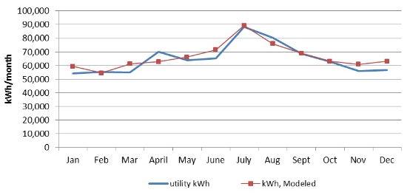

1. *Key model inputs and outputs for each modeling run, including:*
   * *eQuest BEPS and BEPU reports for baseline, each EEM and combined EEM outputs*
   * *Tabular list of values with pre and post EEM (****see example Table A-2 below****)*
   * *Note: All inputs and outputs should match narrative and data presented in the Energy Audit Report (e.g., equipment survey, data logging results, building characteristics narrative, etc.)*

*Along with the summary in the Appendix, firm must send the electronic modeling files (unlocked and unprotected) associated with the energy model.*

***Use of a modeling program does not release energy auditing firms from having to provide a summary of how the EEMs save energy along with the details as to how estimated energy savings were calculated****. Energy auditing firms should fully understand the methodology behind any energy-savings calculations provided by the model, detail this methodology in the Energy Audit Report, and be able to explain the accuracy and reasonableness of any savings estimates to the Contracting Agency and ODOE.*

|  |  |  |
| --- | --- | --- |
| **Table A-2 - Comparison Table of EEM Building Inputs Vs. Baseline Building Inputs** | | |
| **Parameter** | **EEM Modeling Modifications** | **Existing Building Conditions** |
| **Walls** | **EEM 1:** South Wing Only  Ueff-0.060 (R-14 Continuous Insulation over 8” CMU block)  Rest of Building:  Ueff- 0.452 (8” CMU Block) | For entire building:  Ueff- 0.452 (8” CMU Block) |
| **Roof** | **EEM 2:**  Ueff-0.046 (R-21 Insulated Metal Panel) | Ueff- 0.089 (Metal roofing with 2.25” of R-7 Min Wool Batt) |
| **Floors** | Building is slab-on-grade and has R-6 Insulation | Building is slab-on-grade and has R-6 Insulation |
| **Windows** | Existing window-to-wall ratio: 25%,  **EEM 3:** South Wing Only  low E glazing for all windows in South Wing  Ucog- 0.29  SHGC: 0.39  SC: 0.45  (DOE2 Glass Library Code: 6582) Frame: Thermally Broken Aluminum  Rest of Building: Single Pane Glazing Ucog- 1.01  SHGC: 0.89  SC: 0.95  (DOE2 Glass Library Code 1001) Frame: Thermally Unbroken Aluminum | Existing window-to-wall ratio: 25%,  Single Pane Glazing  Ucog- 1.01  SHGC: 0.89  SC: 0.95  (DOE2 Glass Library Code: 1001) Frame: Thermally Unbroken Aluminum |
| **Doors** | Opaque Doors:  Aluminum, hollow with no insulation,  Ueff-2.080  (DOE2 Door Name: Sgl Lyr Unins Mtl Door) | Opaque Doors:  Aluminum, hollow with no insulation, Ueff- 2.080  (DOE2 Door Name: Sgl Lyr Unins Mtl Door) |
| **Infiltration** | Assumed standard modeling practices: Perimeter spaces: .7 ACH  Core spaces: .35 ACH | Assumed standard modeling practices: Perimeter spaces: .7 ACH  Core spaces: .35 ACH |
| **Lighting, power density** | Non-renovation:  Office: 0.67-2.96 W/sqft  Classrooms: 0.76- 2.26 W/sqft  Corridor: 0.93- 1.76 W/sqft  **EEM 4:**  Gym: 1.00 W/sqft | Office: 0.67-2.96 W/sqft  Classrooms: 0.76- 2.26 W/sqft  Corridor: 0.93- 1.76 W/sqft    Gym: 1.96 W/sqft |
| **Equipment** | Office: 1.0 W/sqft  Classrooms ; 0.75 W/sqft  Corridors/Restrooms: 0.0 W/sqft  Storage/Mech: 0.25 W/sqft | Based on equipment inventories: Office: 1.0 W/sqft  Classrooms: 0.75W/sqft  Corridors/Restrooms: 0.0 W/sqft  Storage/Mech: 0.25 W/sqft |
| **Heating system** | Hydronic Fin Tube system remains in some portions of the E and N wing.  **EEM 5:** VRF heat pump system and hydronic heating coils for tempering in ventilation air units serving S wing.  **EEM 6:** Woodshop Heating System:  4 Direct fired gas Tubular Radiant Heaters  **EEM 7:** Improved boiler efficiency Number of boilers: 2  Type of boiler: Condensing Combustion Efficiency: 95%  Capacity: 0.5 Mbtu/hr (416 Tons) each  AFUE: 92%  **EEM 8:** Increased Piping Insulation Temperature loss of water due to heat loss in piping: 0.05F   * 5% of total load on boiler due to pipe losses | Hydronic Fin Tube system throughout all perimeter zones in N, S, E wings.  Baseboard Delta T: 50 F  Woodshop Heating System: 6 Steam Unit Heaters  Boiler: Powerflame Burner Number of boilers: 1  Type of boiler: Steam  Capacity: 2.836 Mbtu/hr (236 tons)  AFUE: 81%  Zoned as currently operated in regards to number of thermostats.  Temperature loss of water due to heat loss in piping: 0.2 F   * 10% of total load on boiler is due to pipe losses |
| **Controls** | **EEM 9**: DDC throughout building.  **EEM 10:** DDC enable zone pumps when associated zones call for heat.  (Based on boiler reset schedule)  **EEM 11:** Occupancy Schedules/ Sensors Zonal occupancy sensors with manual override  Heating setpoint (occ/unocc hrs): 68F / 55F  Cooling setpoint (occ/unocc hrs): 72F / 78F  **EEM 12**: Lower Supply and Return water temperatures  Boiler Supply Temp: 180 F (< 30F OSA)/140 F (>50F OSA)  Boiler Return Temp: 110 F | Pneumatic controls in South wing and DDC in North and East wing  Building wide fan schedule based on typical occupancy:  Mon-Fri: 7AM-5PM  Sat-Sun: Off  Heating setpoint (occ/unocc hrs): 68F / 55F Cooling setpoint (occ/unocc hrs): 72F / 78F  Boiler Supply Temp: 200 F Boiler Return Temp: 150 F |
| **OSA**  **ventilation** | OA rates:  Building CFM total: 2,500 cfm  System: Following systems provide 100% OSA for ventilation only:  SF-4 (450 cfm)  SF-5 (480 cfm)  SF-6 (480 cfm) | OA rates:  Building CFM total: 2,000 cfm |
| **Domestic Hot Water** | **EEM 12:** Gas Water Heater, 90% AFUE  Typical fixture flow rates (faucets, shower heads): 2.5 GPM | Gas Water Heater, 80% AFUE  Typical fixture flow rates (faucets, shower heads): 2.5 GPM |

## ASHRAE Hourly Simulation Checklist[11]





## Equipment Surveys

*The required template for equipment surveys for major equipment types is provided below. Complete the tables below and provide any additional information to fully document all equipment at the facility. Any necessary information or system characteristics that cannot be fully incorporated into the tables should be included in alternative tables and narrative within the report. Where items in the table do not apply to a facility or are unknown, note “N/A” for that item and provide a simple explanation. Variation from the template requires prior approval from ODOE.*

**Equipment Survey: Boilers**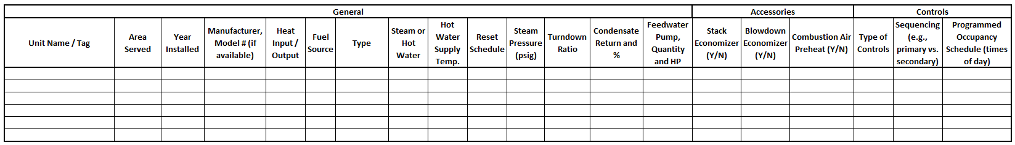

**Combustion Efficiency Test Results**

**Equipment Survey: Chillers**

**Equipment Survey: Cooling Towers**

**Equipment Survey: Airside and Other HVAC System Equipment; Packaged Units**



**HVAC Controls***Provide detailed narrative for building-level/global controllers. Narrative for controls should include:*

* *Age and condition*
* *Type (electronic, pneumatic, combination)*
* *Manufacturer and model number*
* *Areas and equipment controlled*
* *Control configuration and operating sequence.*
* *Control capabilities and limitations (e.g., optimized start, web interface)*
* *Maintenance or operational issues*

## Equipment Survey: Domestic Hot Water



## Equipment Survey: Lighting

*Include all interior and exterior lighting showing specific locations by space type/identification with the actual number and type of existing fixtures. Survey the building to determine connected interior and exterior lighting power and energy usage. Document existing lamp types, wattages, and controls. Document the existence of any hazards materials with disposal requirements.*

***Note:*** *If providing lighting EEM(s) that would incorporate the same elements of this table, the table may be replaced by the* *Baseline and Proposed Lighting Schedule table**. If replaced, include note in this section to “refer to Baseline and Proposed Lighting Schedule” table for this information.*



*Table Instructions:   
See* *Baseline and Proposed Lighting Schedule table* *in the Appendix below.*

## Equipment Survey: Plug loads and Other Equipment

*Include narrative and tables to describe the location, type, and quantity of existing equipment. This could include, but is not limited to:*

* *Computers (desktop and laptops) and Computer Monitors*
  + *Note any existing computer power management programs*
* *Servers and UPS transformers*
* *Office equipment (e.g., printers, fax machines)*
* *Vending machines*
* *Kitchen equipment and food storage*
* *Pool heaters, pumps, and other equipment*
* *Shop or crafts equipment*
* *Vertical transport (elevators, escalators)*
* *Cogeneration, thermal storage, or renewable generation on site*
* *Other specialized equipment (e.g. sports, theater, etc.)*

# EEM Related Appendices

## EEM Specific Requirements

**Controls Measures**

* *Describe proposed control configuration and summary of operating sequence (e.g., overall control strategy with schedule and major control devices). Point by point description not required.*
* *Include training costs for Contracting Agency staff in EEM costs. Also identify if a control service contract is recommended or needed.*
* *List other functions beyond energy management included in system’s design (e.g., security, fire detection, etc.).*
* *Setpoint or scheduling changes that can be accomplished with* ***existing*** *controls equipment should be listed as a separate EEM (e.e.g, as a retro-commissioning measure or* *Low and No-Cost EEMs section**).*
* *Setpoint or scheduling changes that can be achieved with* ***new*** *controls equipment AND are not possible with existing equipment, should be included in a controls upgrade EEM. These changes should be clearly defined in the Proposed Conditions narrative in the* *EEM section**, with additional information included in the Appendices as needed.*

**Lighting Measures (Interior and Exterior)**

* *Provide a detailed lighting schedule (table below) by location with the proposed quantity and type of new lamps and fixtures. While not in the basic table, please include information about ballast type and quantity if relevant to EEM baseline and/or proposed conditions and calculations.*
* *Operating hours should be based on equipment operation. Hours and diversity factor should be be verified by data-logging, interviews, and on-site observation - general facility operating hours is not acceptable.*
* *If relevant to EEM baseline or proposed conditions (e.g., overlit areas, significant fixture count or lumen reduction), include documentation on the measured or calculated lighting levels (e.g., measured foot-candles). When light levels, uniformity, or safety are a concern (e.g. parking lots, pedestrian areas, stairways, and egress points), reference current Illuminating Engineering Society procedures to verify adequate lighting levels. It is the Audit Firm’s responsibility to ensure proposed EEM meets industry standard lighting practices.*
* *When adding or upgrading lighting controls, detail the proposed operation configuration. Include the number, type, and location of new controls. Include explanation, assumptions, or data-logging to support any significant reductions in light levels or operating hours.*
* *Recommend using sketches of new fixture layouts or controls to explain proposed measures.*
* *Calculate the reductions in lighting energy and include any increases or decreases in other forms of energy use, such as increased heating, associated with installing the EEM (see Measure Interaction detailed in the* *EEM section**).*
* *For calculations, include all results, explain methodology and assumptions, and document all key input variables.*

***Note:*** *Use of alternate lighting tools or calculators requires pre-approval with ODOE in the Scope of Work to ensure audit requirements are met and duplicate/conflicting work is minimized.*

**Baseline and Proposed Lighting Schedule**



*Table Instructions*

1. *Space Type: Assign the appropriate space type (e.g., classroom, cafeteria, hallway)*
2. *Fixture Quantity: List the total number of fixtures for that space and fixture type.*
3. *Fixture Type: List the fixture type for the listed space and fixture quantity. This description should include both the mounting style (e.g., recessed, pendant) as well as lamp configuration and count (e.g., 2x4, four-lamp).*
4. *Lamp Type: List the type of lamp for each fixture (e.g., metal halide, fluorescent, LED; tubular, u-shaped, screw-in)*
5. *Total Watts Per Fixture: List the power draw in W associated with each fixture. This should consider lamp wattage, ballasts power draw, and ballast factor.*
6. *Total Power: List the total power draw in kW for each space type. Calculation should use Fixture Quantity and Watts per Fixture, converted to kW.*
7. *Watts per Sq. Ft.: List the average lighting power density (Watts per Sq. Ft.) for each space type. Where there are multiple types of fixtures for a single space type, table should incorporate merged cells for this column to show the room-level total lighting power density. It is not necessary to list the lighting power density for each fixture type for each room.*
8. *Operating Hours: List the total operating hours for the baseline and proposed scenario for the lighting equipment for each space type. Operating hours should be based on equipment operation. Hours and diversity factor should be verified by data-logging, interviews, and on-site observation - general facility operating hours is not acceptable.*
9. *Baseline and Proposed Energy Use (kWh): Calculate the total annual kWh for the baseline and proposed scenarios, using the Total Watts and Operating Hours for each space type.*
10. *Demand Savings (kW): Calculate the reduction in kW demand between the baseline and proposed scenario.* ***Note:*** *Incorporation of demand savings will require additional verification and documentation of how and where demand savings will occur.*
11. *Energy Use Savings (kWh): Calculate the reduction in kWh between the baseline and proposed scenario.*

## Measure Life Table

*This table is for reference only; also listed in the* [*School Program Guidelines*](http://www.oregon.gov/energy/energy-oregon/Pages/SB1149-Program-Guidelines.aspx)

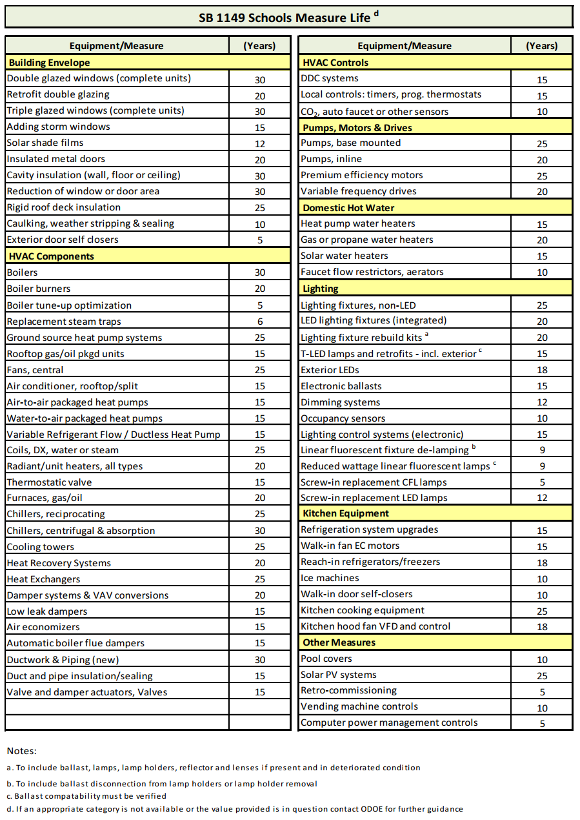

## Multi-Component Measure Life Calculator



*Table Instructions*

1. *List the individual Components, Component Costs, and Measure Life in the respective row and column* 
   1. *Component cost should include the materials, labor, overhead/profit, and contingency costs as described in* *EEM Cost Estimation Table* *instructions*
   2. *Component measure life should be sourced from the* *Measure Life Table*
2. *Multiply the Component Cost by the Measure Life. Put the total in the "Cost * Measure Life" column*
3. *Divide the "Cost * Measure Life" Total by the "Component Cost" Total. Put that value in the Weighted Measure Life box.*

## EEM Energy Calculations

*Include all supporting documentation for EEM Energy Calculations. If a separate electronic file will be provided, note in the appendix and include key documents in this section.   
  
If energy modeling used, firm must provide electronic model files, but must also include a summary of the key model outputs and values for each EEM in the* *Energy Modeling Documentation* *section.*

## EEM Cost Estimation

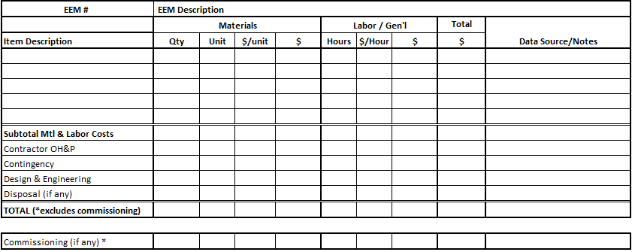

*Table Instructions*

1. *Cost Estimates can be developing using the following sources:*
   1. *Most recent edition of RSMeans Cost Estimating Data (list referenced section and edition used)*
   2. *Bureau of Labor and Industries (must list source and date of published data)*
   3. *Equipment vendor or installer quotes pertaining directly to the EEM. Verbal quotes are not accepted. A copy of quotes must be included in Appendix.*
   4. *Recent projects (within a year) of similar size and scope. Projects must be described, costs listed, and source documents provided.*
   5. *Must cite source and date in “Data Source/Notes” column for all sources.*
2. *Materials & Equipment: Identify vendor and contact person who provided material and equipment estimates. Include dates and sources of information.*
3. *Labor: Must use prevailing wage rates. Include separate “Hours” and “$/Hour” rate. If vendor quotes are used, must state AND verify vendor used prevailing wage rates. Include dates and sources of information.*
4. *Itemize specific costs related to design and engineering, contractor overhead and profit, and contingency, if any. Document the source of estimates, amount, and a brief description that includes assumptions and data sources.*
5. *Disposal & Salvage: Indicate any required or expected disposal costs, including hazardous materials or abatement. Include any salvage value or possible reuse of materials. Document the source of estimates, amount, and a brief description that includes assumptions and data sources.*
6. *TOTAL: Sum all costs (excluding commissioning cost). This TOTAL must match EEM Cost in both the Measure Cost in the* *EEM Summary table* *and in the* *EEM Cost Benefit Analysis table**.*
7. *Commissioning: Include estimated commissioning cost for EEMs that require commissioning (requirements in* *EEM Section**). Commissioning costs are not included in the Measure Cost Total row, but should be described.*
8. *Table Customization/Adaption: Customize as appropriate to accommodate the other elements or itemization. Document and explain any assumptions. Significant customization requires approval by ODOE in advance.*
9. *Add any additional explanation in the “Data Source/Notes” field or narrative below the table.*

## EEM Cut Sheets

*Include manufacturer data or equipment cut sheets where performance data or equipment specifications (e.g., efficiency rating, wattage, size, etc.) were essential in developing the EEM and/or EEM savings. Need only include pages on which data/specifications are shown.*

# Site Measurements Appendices

## Onsite Visits and Monitoring

**Onsite Visits***For each visit, list:*

* Date of Visit
* Purpose of Visit
* Audit Firm and School District Personnel in Attendance
* Critical notes or findings from the Visit

**Monitoring***For each dataset/parameter, list the following:*

* Dates
  + Installed and removed
  + Logging period (if different)
  + For instantaneous/point measurements: List date, time, location.
* Equipment
  + Purpose and Measured Parameter(s)
  + Placement (equipment, location, etc.)
  + Quantity and type
  + Logging Interval(s)
* Any issues, abnormalities that may have affected monitoring data.

## Data Logging and Monitoring Results

*Include summary description of data logging and monitoring methodology. Include monitoring type (e.g., instantaneous, load profile, periodic total) and general approach. Trend data should indicate duration and intervals, with key monitoring graphs and charts included.*

*Must include all key results that support the assumptions and recommendations made in the E*nergy *Audit Report.*

*All charts and graphs should include brief explanation of results and significance to the Energy Audit Report findings. Include annotations to graphs and charts as needed to illustrate key points or explain anomalies.*

# Administrative Appendices

## Report Identification

**Institutional Contacts**  
*List the name, address, phone, and email for each:*

* Superintendent
* Facilities Manager
* Business Manager
* Building Operator/Maintenance Staff/Other

**Report Preparer**  
*List the name, address, phone, and email for each:*

* Energy Auditing Firm
* Energy Auditor
* Senior Reviewer
* Energy Modeler

## Signatures and Certifications

**ENERGY AUDITOR CERTIFICATION**

Energy Auditor:

As an independent, consulting energy auditor, I am not directly responsible for the day-to-day operation of the building or operation being studied. I have no conflict of interest relating to this study or any energy efficiency measures (EEMs) considered in this study.

I have calculated the total energy cost savings, by fuel type, expected to result from the acquisition and installation of each proposed EEM. The energy prices used in this report are the current prices the building is expected to pay based on the most recent billing history of the building(s).

As a professional energy auditor, I hereby certify that I have discussed any operation and maintenance procedures needing to be addressed and implemented with the building operator and facility manager.

I hereby certify that this study has been prepared by me or under my direct supervision and all information contained herein is correct to the best of my knowledge. I am listed as a qualified lead energy auditor for schools with the Oregon Department of Energy and am qualified to perform energy studies on commercial buildings.

Energy Auditor’s Printed Name Signature Date

**ENERGY MODELER CERTIFICATION**

Energy Modeler:

As a professional energy modeler, I hereby certify that I have modeled the building to the best of my ability using the building characteristics and existing equipment as provided by the lead energy auditor. The model incorporates the proposed EEMs to provide the estimated energy savings from the existing systems along with the interactions between the systems proposed for installation.

I am listed as a qualified energy modeler for schools with the Oregon Department of Energy and am qualified to perform energy savings calculations using annual hourly models on commercial buildings and systems.

Energy Modeler’s Printed Name Signature Date

**SENIOR REVIEWER CERTIFICATION**

Senior Reviewer:

As a senior reviewer, I hereby certify that I have reviewed this study for accuracy and completeness and that it is correct to the best of my knowledge. I hereby certify that our firm has followed our firm’s internal quality control process, and that this study has been adequately reviewed by our firm’s staff. I hereby certify that this study meets all requirements outlined in the Scope of Work Approval Form, the contract between our firm and the Contracting Agency, and all other Program requirements. I am listed as a senior reviewer of energy studies for schools with the Oregon Department of Energy and am qualified to perform energy studies on commercial buildings.

Senior Reviewer’s Printed Name Signature Date

1. ASHRAE, *Procedures for Commercial Building Energy Audits, 2nd Edition* (Atlanta: ASHRAE, 2011), 133. Due to program requirements, a column for EUI changes was added to the table, while columns for Utility Incentives, Net Measure Costs, IRR and NPV are not needed and were eliminated from this table.
2. ANSI/ASHRAE/IES Standard 100-2015 Energy Efficiency in Existing Buildings: Section 8.5.5
3. ANSI/ASHRAE/IES Standard 100-2015 Energy Efficiency in Existing Buildings: Section 8.5.5.2
4. ASHRAE, *Procedures for Commercial Building Energy Audits, 2nd Edition* (Atlanta: ASHRAE, 2011), 3, 6-7, 26-29.
5. ASHRAE, *Commercial Building Energy Audits*, 63-64.
6. ANSI/ASHRAE/IES Standard 100-2015 Energy Efficiency in Existing Buildings: Section 8.5.5.2
7. ASHRAE, *Commercial Building Energy Audits*, 11.
8. ANSI/ASHRAE/IES Standard 100-2015 Energy Efficiency in Existing Buildings: Section 8.5.1
9. ASHRAE, *Commercial Building Energy Audits*, 127.
10. ASHRAE, *Commercial Building Energy Audits*, 136-137.
11. ASHRAE, *Procedures for Commercial Building Energy Audits, 2nd Edition*